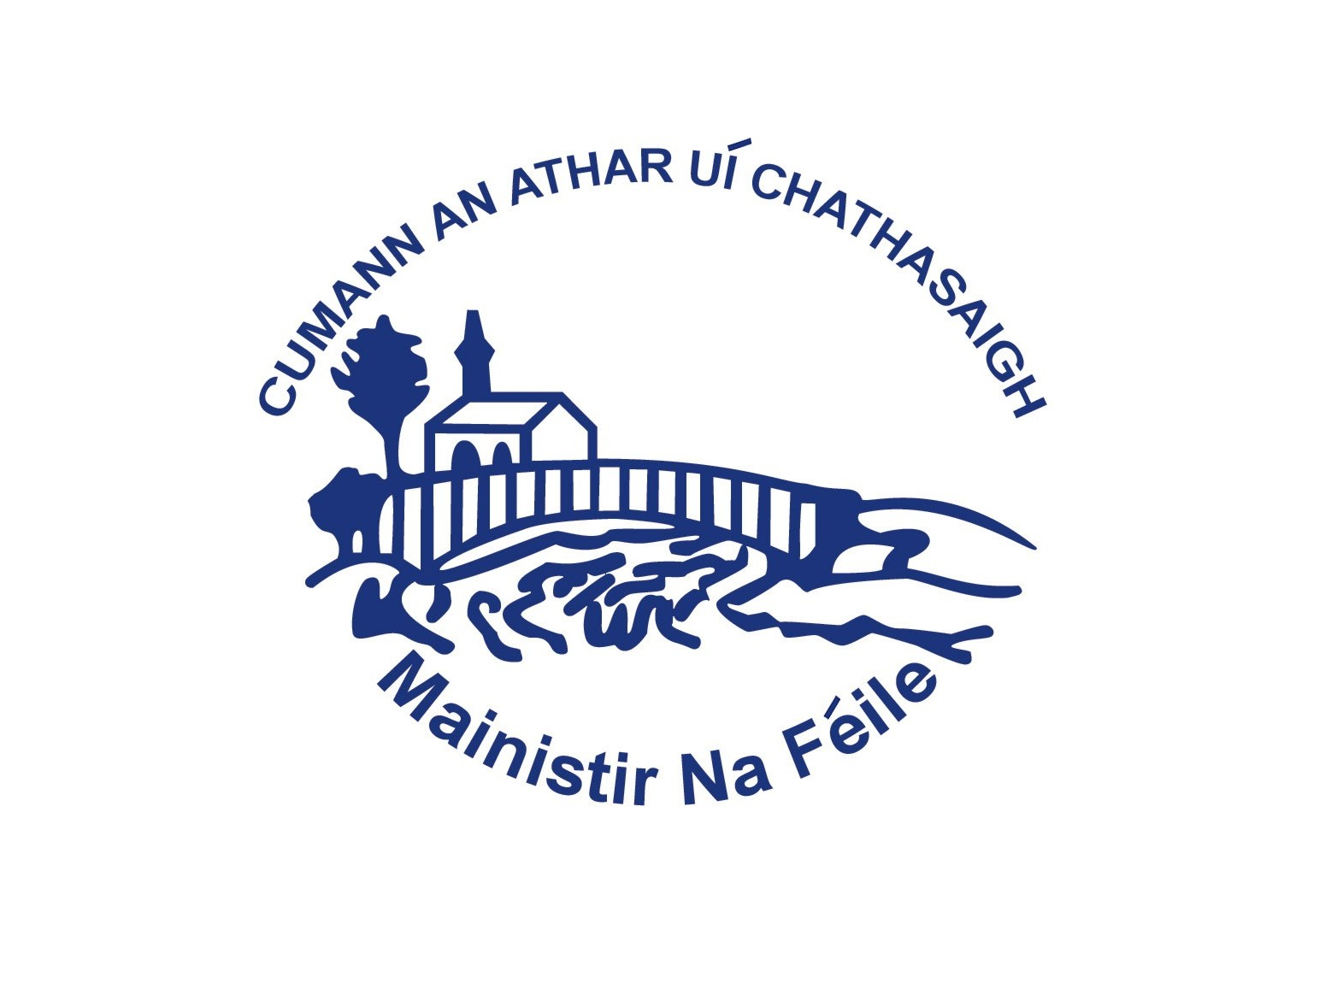
Fr. Casey’s GAA Club
Cumann an Athar Uí Chathasaigh
Mission Statement

Fr. Casey’s G.A.A. Club is fully committed to the promotion and preservation of Gaelic Games and culture through sustained community effort.

We aim to foster an environment where there is total dedication to social responsibility, where leadership qualities in our youth are encouraged and developed, enabling them to take accountability and ownership of designated club activities and instil in them lifetime values.

Our club values all children, young people and adults of our community irrespective of their gender, civil or family status, age, disability, sexual orientation, religious belief or membership of the Traveller community. Fr. Casey’s extends a special welcome to immigrants and non-nationals and will encourage and support their integration into the community, through the club’s activities.

We undertake to enforce and maintain a strict code of conduct, where the dignity of the individual is upheld and always protected and where any form of behaviour, that could be construed as being of threatening, intimidating or of a bullying nature will not be engaged in nor tolerated. The club also recognises that all involved in working with children and young people have a special duty of care towards them and have appropriate procedures in place.

Fr. Casey’s treasure the uniqueness of each club member and pledge to engage with them and our community in an open, honest and transparent manner.
We regard Fr. Casey’s as a community that prizes and encourages an atmosphere of respect, discipline, security and harmony in which quality coaching and athletic skills are nurtured and developed.

Ratified at Executive Committee Meeting.

