Cumann an Athar Uí Chathasaigh
Fr. Casey’s Bord na nÓg

The following information has been extracted from the GAA Code of Behavior (Underage) publication, agreed by the Gaelic Athletic Association, Ladies Gaelic Football Association, the Camogie Association, GAA Handball Ireland and the Rounders’ Council of Ireland and brings together the collective good practice experiences of these Associations.

The full publication is available to download from the Fr. Casey’s GAA website http://www.frcaseysgaa.ie

Code of Behavior (Underage)

The Code of Behavior addresses the minimum appropriate levels of behavior, practice and conduct required from our Young Players, Coaches, Supporters, Parents/Guardians, Referees and Clubs.

The Gaelic Athletic Association, the Camogie Association, Ladies Gaelic Football Association, GAA Handball Ireland and the Rounders Council of Ireland have endorsed this Code so that it may act as a guidance for those who promote and deliver our Gaelic Games and assist them in complying with the highest possible standards in our work with children and young people.

Everyone involved in our sports and in our activities should accept the roles and responsibilities that they undertake as we commit ourselves to maintaining an enjoyable and safe environment for all. The safeguarding of our members will always be a key priority as we recognize that the welfare of the child is of paramount importance in our work.

It is recommended that Coaches, Parents/Guardians and Players sign this Code of Behavior and present the signed document, as a commitment of its implementation, to their Club Children’s Officer.

Our aim is to ensure that young people and children who play our games receive the best possible care, attention and protection while participating in our Gaelic Games.

Should a breach of the Code be alleged, or when people may refuse to adhere to the contents of the Code, certain actions may be deemed necessary and appropriate so as to protect the integrity of our work with children and young people and also to ensure that they receive the best possible care, attention and protection while participating in our Games.

Alleged breaches of this Code may therefore be enquired into, regardless of where or when they occur, in accordance with the guidance contained in this Code of Behavior document. Following any such enquiry, and where deemed necessary, sanctions or disciplinary action may be taken against those who have been proven to have breached the Code.

This Code applies to all underage players and those who assist them in the preparation and playing of our games, regardless of competition or age group. Clubs, County Boards and Games Officials who are responsible for organizing our games at all levels are obliged to implement this Code in the preparation of their teams and players for all competitions and at all other levels including Club blitzes and competitions, County development squads and Inter -County games.
It is our wish that this Code is developed, promoted and implemented as an initiative that encourages fair play, respect, equality, safety and non-discrimination in all aspects of our work with children and young people.

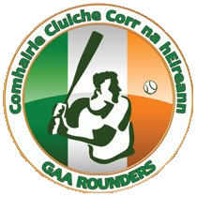
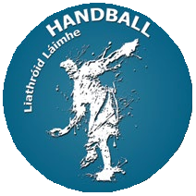

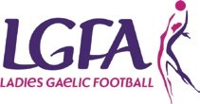

Young Players
Young Players can benefit greatly from sports in terms of personal development and enjoyment. Our players are encouraged to realise that as a result of their participation in our Gaelic Games that they also have a responsibility to treat other players and officials with fairness and respect. With rights there will always be responsibilities.

Young Players, and those who work with them in our Associations are required to ‘sign up’ and abide by this Code of Behavior and to any other policies or codes in your Club or National Governing Body.

YOUNG PLAYERS SHOULD BE ENTITLED TO:

- Be safe and feel safe.
- Have fun and experience a sense of enjoyment and fulfilment.
- Be treated with respect, dignity and sensitivity.
- Comment and make suggestions in a constructive manner.
- Be afforded appropriate confidentiality.
- Participate in games and competitions at levels with which they feel comfortable.
- Make their concerns known and have them dealt with in an appropriate manner.
- Be protected from abuse.
- Be listened to.

YOUNG PLAYERS SHOULD ALWAYS

- Play fairly, do their best and enjoy themselves.
- Respect fellow team members regardless of ability, cultural or ethnic origin, gender, sexual orientation or religious beliefs.
- Support fellow team members regardless of whether they do well or not.
- Represent their team, their Club and their family with pride and dignity.
- Respect all Coaches, Officials and their opponents.
- Be gracious in defeat and modest in victory.
- Shake hands before and after a game as part of the Give Respect Get Respect initiative, irrespective of the result.
- Inform their Coach/Mentor/Manager in advance if they are unavailable for training and games.
- Take due care of Club equipment.
- Know that it is acceptable to talk to the Club Children’s Officer with any concerns or questions they may have.
- Adhere to acceptable standards of behavior and their Club’s Code of Discipline.
- Tell somebody else if they or others have been harmed in any way.

YOUNG PLAYERS SHOULD ENGAGE IN GOOD PRACTICE:

- Never cheat – always play by the rules.
- Never shout at or argue with a game’s official, with their Coach, their teammates or opponents and should never use violence.
- Never use unfair or bullying tactics to gain advantage or isolate other players.
- Never spread rumors.
- Never tell lies about adults or other young people.
- Never play or train if they feel unwell or are injured.
- Never use unacceptable language or racial and/or sectarian references to an opponent, a fellow player or official by words, deeds or gesture.
- Never consume non-prescribed drugs or performance enhancing supplements.
Parents/Guardians
Parents/Guardians have an influential role to play in assisting and encouraging their children to fully
participate in Gaelic Games, whether by playing our games or attending training or coaching sessions.

In common with Coaches and Club personnel the Parents/Guardians of underage players should act as role models for their children as they participate in Gaelic Games.

PARENTS/GUARDIANS SHOULD ENCOURAGE THEIR CHILD TO:

- Always play by the rules.
- Improve their skills levels.
- Appreciate everybody on their team, regardless of ability.
- Maintain a balanced and healthy lifestyle with regard to exercise, food, rest and play. Advice may be sought if necessary from Club officials on this issue.

PARENTS/GUARDIANS SHOULD LEAD BY EXAMPLE:

- Adopt a positive attitude to their children’s participation in our games.
- Respect officials’ decisions and encourage children to do likewise.
- Do not exert undue pressure on your child.
- Never admonish your own child or any other child for their standard of play.
- Be realistic in their expectations.
- Show approval for effort, not just results.
- Avoid asking a child or young person, ‘How much did you score today’ or ‘What did you win by’ or
‘What did you lose by.’ Ask them ‘Did they enjoy themselves.’
- Never embarrass a child or use sarcastic remarks towards a player.
- Applaud good play from all teams.
- Do not criticize playing performances. Identify how improvements may be made.
- Do not seek to unfairly affect a game or player.
- Do not enter the field of play unless specifically invited to do so by an official in charge.

PARENTS/GUARDIANS SHOULD:

- Complete and return the registration/permission and medical consent forms for their child’s participation in the Club.
- Inform the Coaches, and any other relevant Club personnel, of any changes in their child’s medical or dietary requirements prior to coaching sessions, games or other activities.
- Ensure that their child punctually attends coaching sessions/games or other activities.
- Provide their child with adequate clothing and equipment as may be required for the playing of our games including for example helmets, shin guards, gum shields etc.
- Ensure that the nutrition/hydration and hygiene need of their child are met.
- Never encourage your child(ren) to consume non-prescribed drugs or take performance enhancing supplements.
- Listen to what their child may have to say.
- Show approval whether the team wins, loses or draws a game.
- Never attempt to meet their own needs and aspirations for success and achievement through their children’s participation in games.
- If a parent has any issues to raise regarding their child’s participation or performance in a team they may raise this with the team coach(es) but should do so in a constructive and non-confrontational manner and not in the company or vicinity of young players or other parents.
- Complaints about the conduct or practice of a coach should be brought to the attention of the relevant Club or County Children’s Officer.
- Support your Club by becoming an active member and by participating in club activities.

PARENTS/GUARDIANS SHOULD ASSIST THEIR CLUB BY:

- Showing appreciation to volunteers, coaches and Club officials.
- Attending training and games on a regular basis.
- Assisting in the organizing of Club activities and events as requested.
- Respecting the rights, dignity and worth of every person and by treating each one equally regardless of age, gender, ability, ethnic origin, cultural background or religion.
- Not entering team dressing rooms unless deemed necessary by the team coach (es) so as to protect the privacy of other underage players.

PARENTS/GUARDIANS HAVE THE RIGHT TO:

- Know their child is safe and to make a complaint if they believe that their child’s safety is in any way compromised.
- Be informed of problems/concerns relating to their child.
- Be informed if their child gets injured.
- Complain if they have concerns about the standard of coaching.
- Have a say in relation to decisions being made within the Club.

Supporters
Young Players are eager to enjoy and benefit from the support they receive from parents, guardians, friends and other members of the Club who attend our games as spectators and supporters. Active, loyal and well-behaved supporters are always welcome to attend and support our games but should be aware that their conduct will reflect upon the team, players and Clubs that they support and represent.

Fellow supporters have a responsibility to ensure that all spectators conduct themselves in an acceptable and well-behaved manner at all times, when attending our games and competitions. Unacceptable conduct by supporters should be reported to stadium stewards or officials in charge.

Supporters should realize and consider that Young Players are encouraged to participate in Gaelic Games so that they may enjoy themselves while also improving their skills levels.

SUPPORTERS ADD TO THE ENJOYMENT OF OUR GAMES BY:

- Applauding good performance and efforts from your Club’s players and from your opponents, regardless of the result.
- Condemning the use of violence in any form, be it by fellow spectators, coaches, officials or players.
- Encouraging players to participate according to the rules and the referees’ decisions.
- Demonstrating appropriate behavior by not using foul language or harassing players, coaches or officials.
- Not entering the field of play, before, during or after a game, unless specifically invited to do so by an official in charge.
- Respecting the decisions of all officials.
- Never ridiculing or scolding a player for making a mistake during games or competitions.
- Showing respect to your Club’s opponents. Without them there would be no games or competitions.
- Upholding the principles of FAIR PLAY and RESPECT for all.

Referees
Throughout this Code of Behavior emphasis has been placed on the need to co-operate with and facilitate those who organize and deliver our games and activities. Referees are key people in the delivery of our games and should be respected and assisted in their roles.

Referees are conscious of the fact that they are instrumental in ensuring our games are played in a sporting manner in accordance with the rules of the game.

Players, Coaches, Mentors, Parents/Guardians and other Club personnel have a key role to play in the delivery of this aspect of our Gaelic Games particularly when working with underage players. The manner in which we accept the role, authority and decisions of a Referee will naturally be scrutinized very closely by our underage players.

Players, Coaches, Supporters, Parents/Guardians and other Club personnel should recognize the pivotal role that Referees play in our underage games and should support them at all times when fulfilling their roles.

GIVE RESPECT - GET RESPECT

Give Respect – Get Respect is an awareness campaign that seeks to ensure that Gaelic Games are promoted and played in a positive, fair and enjoyable manner and where Players, Coaches, Spectators and Referees Give Respect – Get Respect from each other.

The RESPECT campaign applies at all levels and amongst all players regardless of age, competition or ability. The key participants in the Give Respect – Get Respect campaign are not just the Players themselves but Coaches, Clubs, Parents, Referees and Supporters.

The Give Respect – Get Respect initiative is supported by the GAA, Ladies Gaelic Football Association, the Camogie Association, GAA Handball Ireland and the Rounders Council of Ireland.

THE RESPECT CAMPAIGN HIGHLIGHTS THE FOLLOWING GOOD PRACTICES:

- All players and coaches shake hands with their opponents and the referee before and after each game.
- Mark out a designated spectators’ area around the playing area.
- At relevant underage categories teams should strive to achieve the maximum participation of all players in accordance with agreed playing models.
- The host Club should welcome referees and opposing teams to all games.
- A merit award, based on sporting endeavor and fair play, shall be awarded to players and teams who have upheld the RESPECT principles.
- Adopt and implement the Code of Behavior when working with underage players as the minimum level of agreement between the Club and players, coaches, parents, guardians and supporters at underage level.
- Organize half time exhibition games during Club and inter County League and Championship Games that promote the principles of the RESPECT campaign in association with Schools, other Clubs and Cumann na mBunscol.

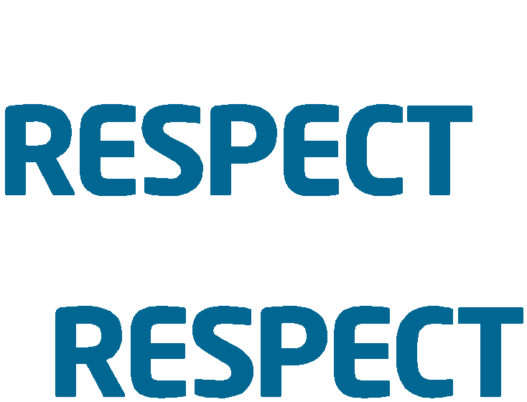

RESPECT • RESPONSIBLE
• ENCOURAGING
• SUPPORTIVE
• POSITIVE
• ENABLING
• CONSIDERATE
• TOLERANT

GAA Anti-Bullying Policy Statement

The GAA aims to create a supportive environment where any form of bullying is unacceptable. We adopt a whole organizational approach to addressing bullying and are committed to implementing structures and relevant training to deal with allegations of bullying. Incidents of bullying are regarded as serious breaches of our Code of Behavior (Underage). We are committed to achieving an ethos of respect so as to maximize the potential of all our members when playing or participating in our Gaelic Games.

DEFINITION

Bullying is defined as repeated aggression, be it verbal, psychological or physical, conducted by an individual or group against others.

THE GAA SEEKS TO ENSURE THAT:

- Incidents of bullying behavior are addressed appropriately

- All persons in membership of the Association or attending our games or activities are aware that bullying behavior is unacceptable in the GAA.

DEALING WITH BULLYING

The Code of Behavior when working with underage players provides good practice guidance in relation to the prevention of bullying.

If you are aware of or have a concern that bullying behavior is happening within your Club, you should report the matter to your Club Children’s Officer.

We recognize that incidents of bullying are a breach of the Code of Behavior and of our Give Respect – Get Respect initiative and all such incidents will be dealt with accordingly.

Pat O’Callaghan
Donal O’Connor
Bridget Daughton 31st January 2020
------------------------------------------------------------------------------------------------------------------------------------------------------------- ------------------------------------------------------------------------------------------------------------------------------------------------------
Children’s Officers Date

Fr. Casey’s GAA Club

Please sign and return this page to your Club Children’s Officer or other nominated official in your Club.

This Code of Behavior addresses the minimum levels of behavior, practice and conduct required from our Young Players, Coaches, Officials, Managers, Supporters, Parents/Guardians and Clubs.

DECLARATION

I _____________________________________________(Parent / Guardian, print name) acknowledge that I have received a copy of relevant extracts from the GAA publication, Code of Behavior (Underage), which I have read and understood. I agree to be bound by the principles set out in the Code when participating, playing or attending our Gaelic Games.

Signed: ________________________________ (Player) Date: _____________

Signed: ________________________________ (Player) Date: _____________

Signed: ________________________________ (Player) Date: _____________

Signed: ________________________________ (Parent / Guardian) Date: _____________

